“SYNOPSIS DIGITAL CLOCK”

Submitted in the partial fulfillment of the requirement for the award of degree of
BAECHLOR IN COMPUTER APPLICATIONS (BCA)



DEPARTMENT OFCOMPUTERAPPLICATIONS UTTARANCHAL SCHOOL OF COMPUTING SCIENCES

Under the supervision of: Submitted by:
Mr. AAGMAN KAPARWAN AASTHA BANSAL
Assistant Professor BCA-II(E)
USCS 2509000003

ACKNOWLEDGEMENT

The most awaited moment of any endeavor is successful completion, but nothing can be done successfully if done alone. Success is the outcome of contribution and consistent help of various persons and we thank those ones who helped us in successful completion of this project.

Primarily I would like to thank Prof (Dr.) Sonal Sharma, Director-USCS for providing a healthy and encouraging environment to study.

I profusely thankful to the Prof (Dr.) Sameer Dev Sharma, Head of Department-USCS for providing all the required resources in the successful completion of my project report.
I express my thanks to Mr. Aagman Kaparwan, Project Mentor, Assistant Professor-USCS. He has been generous enough to provide me an opportunity and accepting my candidature for the most valuable guidance and affordable treatment given to us at every stage to boost my morale.

AASTHA BANSAL
BCA-II (E)

DECLARATION

I, AASTHA BANSAL, hereby declare that the project report entitled "Digital Clock “submitted in partial fulfillment other requirements for the degree of [BCA] is my own original work. The content presented in this report has not been submitted to any other university or institution for the award of any degree or diploma. All sources of information have been duly acknowledged.

AASTHA BANSAL
BCA-II (E)

CERTIFICATE OF ORIGINALITY

This is to certify that the project report entitled "Digital Clock “is a bonafide record of the work carried out by AASTHA BANSAL in partial fulfillment of the requirements for the award of the degree of [BCA] from the USCS Department, Uttaranchal University, Dehradun during the academic year [2026].

The work presented in this report is origin a land has not been submitted elsewhere.

Project guide: Mr. Aagman Kaparwan

Table of Contents

S.NO TITLE PAGE NO.
- Acknowledgement i
- Certificate of originality ii
- Declaration iii
- Table of content iv
- Introduction 1
- Objective 2
- Hardware and Software Requirements 3
- System Analysis 4
- Feasibility study 5
- Project planning 7
- Project Scheduling 8
- Data Models (System Design) 10
- Methodology 16
- Coding 19
- Reference 24

INTRODUCTION

Time keeping has been a fundamental human endeavor since ancient civilizations. The journey from sundials and water clocks to modern atomic clocks represents a relentless pursuit of precision and convenience. The 20th century marked a significant shift with the advent of digital electronics, leading to the replacement of mechanical analog clocks with digital clocks.

A digital clock displays the time numerically (e.g., 10:49), as opposed to an analog clock, which uses moving hands on a dial. This project focuses on the design and implementation of a multifunctional digital clock application. This software-based clock aims to provide not only the basic functionality of time display but also to incorporate modern features such as alarms, a stopwatch, and a timer, all accessible through an intuitive graphical user interface (GUI).

The primary motivation behind this project is to create a lightweight, user-friendly, and customizable time keeping tool that improves upon the basic clock applications bundled with most operating systems. It serves as a practical application of software engineering principles, from requirement analysis and system design to implementation and testing.

OBJECTIVES

The primary objective of this project is to design and develop a fully functional desktop digital clock application. The specific goals are outlined below:

Primary Objectives:
- To accurately display the current system time in HH:MM:SS format.
- To show the current date, day, and year.
- To implement a user-friendly and visually appealing graphical interface.
- To develop a functional alarm system that allows users to set, enable, disable, and delete multiple alarms.
- To include a stop watch feature with start, stop, lap, and reset functionalities.
- To build a countdown timer that a user can set for a specific duration.

Secondary Objectives:
- To allow customization of the clock's appearance (e.g., color themes, font styles).
- To ensure the application is resource-efficient and has a minimal impact on system performance.
- To provide clear audio-visual notifications for alarms and timers.

.

- HARDWARE AND SOFTWARE USED

To successfully develop and run the Digital Clock application, the following minimum hardware and software resources are required.

Hardware Requirements
Table3.1: Hardware Requirements

Component | Specification
Processor | IntelCorei3(4thGen)or equivalent
RAM | 4 GB
Hard Disk | 500 MB of free space
Display | 1024 x 768 resolution or higher
Sound Card | For audio notifications Export to Sheets
Software Requirements

Table3.2: Software Requirements

Component | Specification
Operating System | Mac OS 10.15+
Programming Language | C++ language
IDE/Editor | VS Code, or similar
Version Control | Git Export to Sheets

SYSTEM ANALYSIS
System analysis is the process of studying a system to identify its goals and purposes and to create systems and procedures that will achieve them efficiently.

Identification of Need

In today's fast-paced world, efficient time management is crucial. While all operating systems come with a built-in clock, they often lack advanced features like multiple alarms, a robust stopwatch, or customizable timers. Users often resort to third-party applications that may be bloated with ads or unnecessary features. There is a need for a simple, clean, and multifunctional digital clock application that consolidates essential timekeeping tools into one lightweight package.

Existing System

Most standard operating system clocks (like the one in the Windows task bar) offer very limited functionality.
Drawbacks:
- They typically only display the time and date.
- Alarm functionality is often basic, allowing only one or a few alarms.
- They usually lack integrated stop watch and timer features.
- Customization options for appearance are minimal or non-existent.
- Users must navigate to separate “Alarms & Clock" applications to access more features, which is not always convenient.

Proposed System

The proposed Digital Clock application is designed to overcome the limitations of existing systems. It will be a standalone desktop application that provides a comprehensive suite of time management tools in a single, intuitive interface.
Advantages:
- All-in-One: Integrates clock, multiple alarms, stopwatch, and timer in one window.
- Lightweight: Design to consume minimal system resources.
- Accessible: Key functions are readily accessible without navigating through multiple menus.

- FEASIBILITYSTUDY

A feasibility study is conducted to evaluate the viability of the proposed project. It assesses whether the project is technically, economically, and operationally achievable.

Technical Feasibility:

This assesses whether the required technology and expert are available to develop the project.
- Technology: The project will be developed using C++ high- level, widely supported language, making it readily available on most systems. No specialized or proprietary technology is needed.
- Expertise: The skills required for this project are commonly available and fall within the scope of our development capabilities.
- Conclusion: The project is technically feasible. The necessary tools are open-source and well-documented.

Operational Feasibility:

This assesse show well the proposed system solves the problems and how it will be accepted by the end-user.
- Integration: As a stand-alone application, it does not disrupt any existing work flows. It runs independently.
- Acceptance: Given the limitation so default system clocks, a more feature-rich and customizable application is likely to be well-received by users seeking better time management tools.
- Conclusion: The system is simple to operate and provides clear advantages over existing tools, making it operationally feasible.

Economic Feasibility:

This involves a cost-benefit analysis is of the project.
Costs:
- Development Cost: The primary cost is the time and effort of the developer.
- Software Cost: The project will be built using free and open-source software (C++, VS Code), so there are no licensing fees.
- Hardware Cost: No special hardware is required; a standard personal computer is sufficient.
- Benefits: Provides a practical learning experience in software development.
- The final product is a useful utility for personal time management.
- Conclusion: Since the direct money and cost is negligible, the project is economically feasible.

PROJECT PLANNING

The project will be developed using an iterative approach, broken down in to the following distinct modules:
Module1: Core Clock Engine
- Task1.1: Develop the logic to fetch and continuously update the system time.
- Task1.2: Implement the logic for displaying the date and day.
Module2: Graphical User Interface (GUI)
- Task2.1: Design the main window layout.
- Task2.2: Create display labels for time, date, and other functions.
- Task2.3: Implement navigation between different modes
Module3: Alarm Functionality
- Task3.1: Design the UI for setting, viewing, and deleting alarms.
- Task3.2: Implement the backend logic to check for alarm triggers.
- Task3.3: Integrate audio-visual notifications for triggered alarms.
Module4: Testing and Deployment
- Task5.1: Perform unit testing for each module.

PROJECT SCHEDULING

Gantt chart

The Gantt chart below visualizes the project time line based on the tasks listed above.

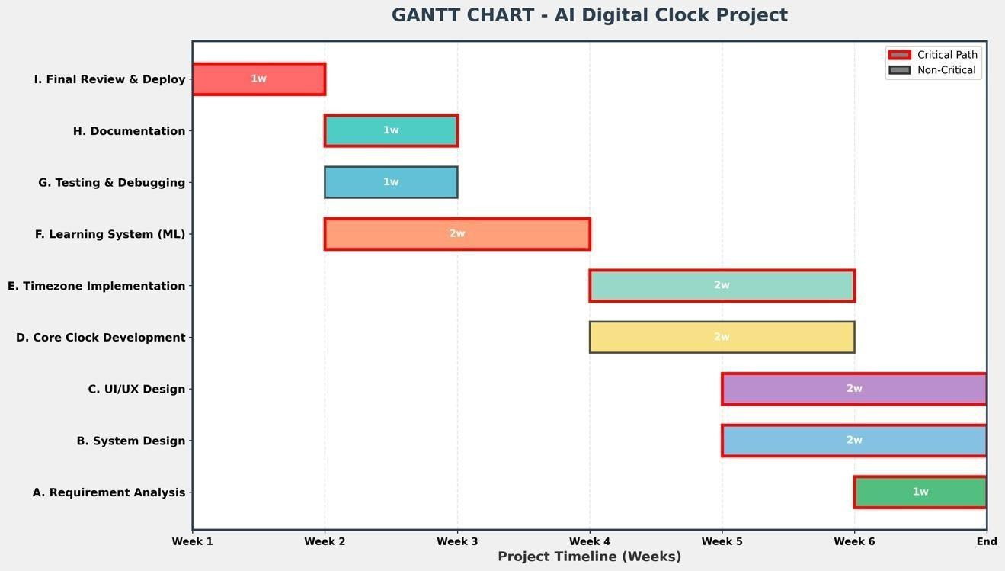

Figure7.1: Gantt chart

The Gantt chart visualizes the project time line across 6 weeks, showing the duration and scheduling of each task:

- Week 1:Requirement Analysis-Gathering requirements for time zone support, real-time display, and ML learning features
- Week 2: Designing system architecture and creating menu interface
- Week 2-3:Core Clock Development-Implementing basic time display and date functions
- Week 3-4:Time zone Implementation & Learning System (parallel)-Adding 5 countries support and AI learning history
- Week 4-5:Testing & Documentation (parallel)-Comprehensive testing and writing user manuals
- Week 6:Final Review & Deployment-Final testing and production release

The PERT (Program Evaluation and Review Technique) chart shows the sequence and dependencies between tasks:

Critical Path (Red): A→B →D→E→G →H→I(Total: 6 weeks)
Task Dependencies:
- System Design (B) can not start until Requirements are complete (A)
- Core Development (D) depends on System Design (B)
- Time zone Implementation (E) requires Core Development (D)
- Testing (G) needs both Time zone (E) and Learning System (F) complete
Parallel Tasks: UI/UX Design (C) and Learning System (F) can run con currently with other
tasks.

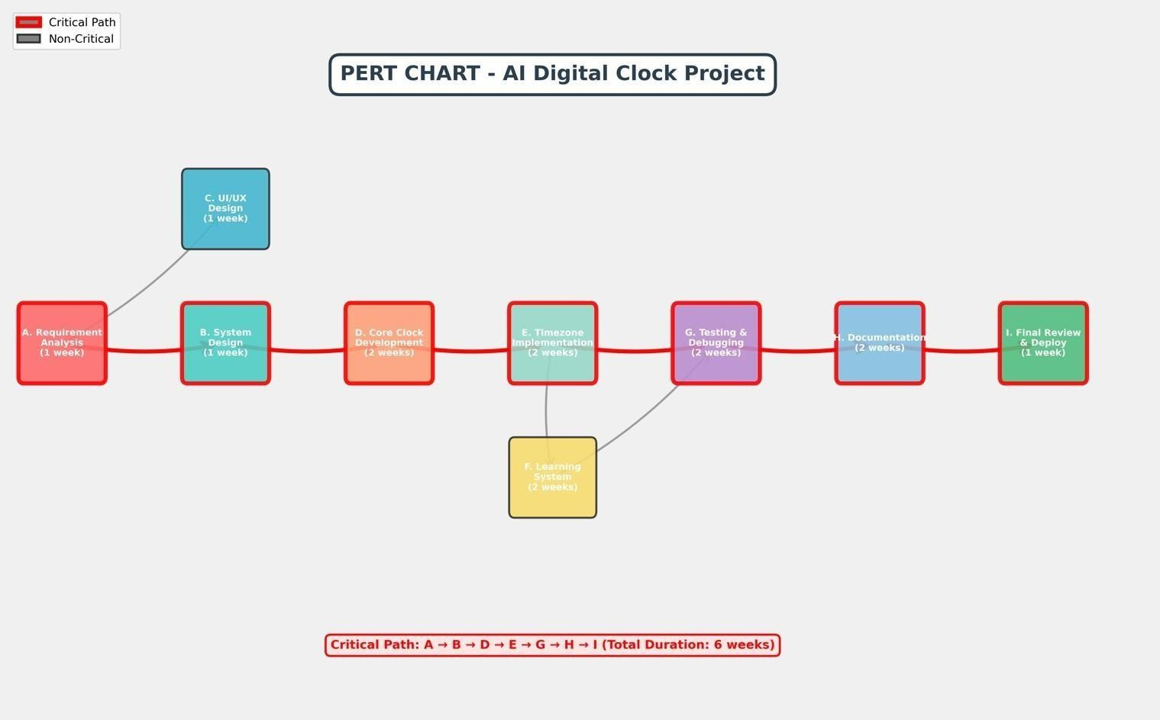

Figure7.2: PERT Chart

DATA MODELS

This section illustrates the system's design using standard modeling diagrams.
Data Flow Diagram (DFD)
The Context Level DFD shows the entire system as a single process with external entities:

External Entities:
- USER : Provides menu choices and time zone selections
- System Clock: Provides current system time from the operating system Main Process: AI Digital Clock System-Processes all inputs and generates outputs.

Data Flows:
- User Input→ System (menu choices, time zone selection)
- System Time→ System (current time from OS)
- System→ Clock Display (formatted time output)

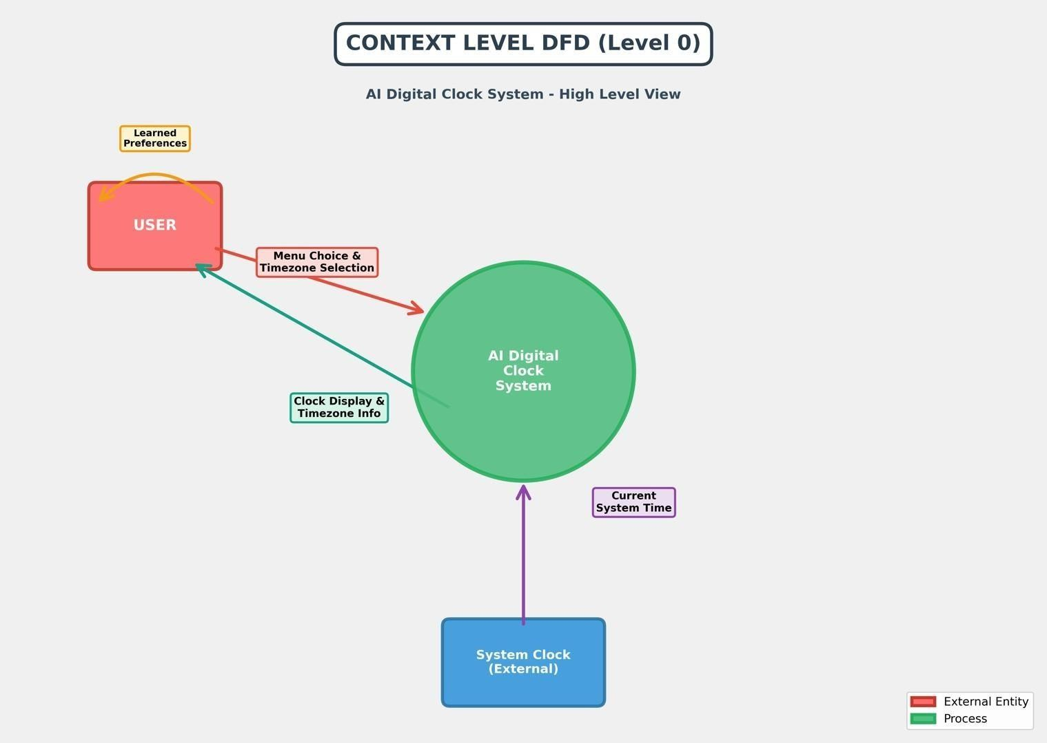

Figure8.1: Context Level DFD (Level 0)

First Level (Level1):

The Level 1 DFD breaks down the main system into detailed sub processes:

- Process1.0-Display Clock: Shows real-time or continuous clock with current time zone.
- Process2.0-ChangeTime zone: Allows user to select new time zone from 5 countries or custom off set.
- Process3.0-View History: Displays previously learned time zone preferences.
- Process4.0-Get Time: Retrieves system time and applies time zone of set calculations.
- Process5.0- Learn Time zone: Saves selected time zone to history (Ai learning component).
- DataStoreD1: Time zone History –Stores last 3 time zone preferences in memory.

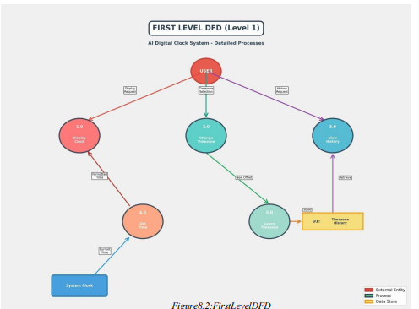

Use Case Diagram:
The Use Case Diagram shows interactions between actors and system functionalities:

- Primary Actor-USER: Main user who interacts with the clock system
- Secondary Actor-System Clock: External system providing time data

Use Cases:
- View Real-Time Clock: Display clock for 10 seconds.
- View Continuous Clock: Display until user stops (Ctrl+ C).
- Time zone: Choose from USA, India, China, UK, France or custom.
- View Learning History: Show last 3 used time zones.
- Auto-Detect Time zone: Detect system time zone on startup.

Relationships:
- <<Include>>: Select Time zone includes Learn Time zone (every selection is learned).
- <<Extend>>: Auto-Detect extends system startup.

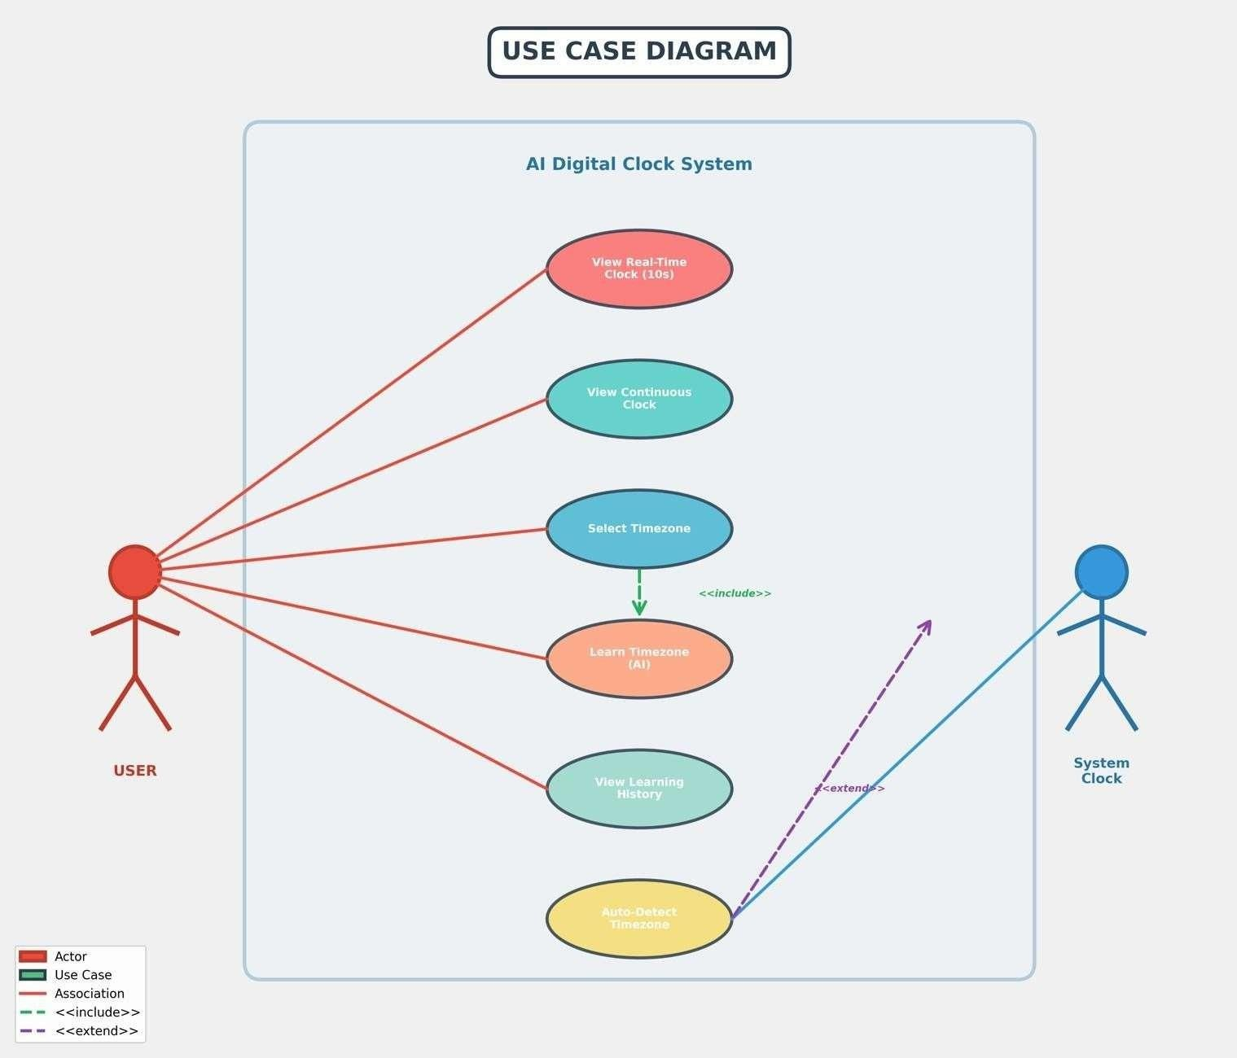

Figure8.3: Use Case Diagram

Class Diagram:
The Class Diagram shows the object-oriented structure of the system:

Clock System (Main Control):
Methods:main(), show_menu(), clear_screen()
Purpose: Main program controller and menu system
Time zone Manager:
- Methods: getWorldTime( ),
Purpose: Handle all time zone operations
Clock Display:
- Methods: showworldclock(),runtimer().
Purpose: Handle all time display formatting and updates.

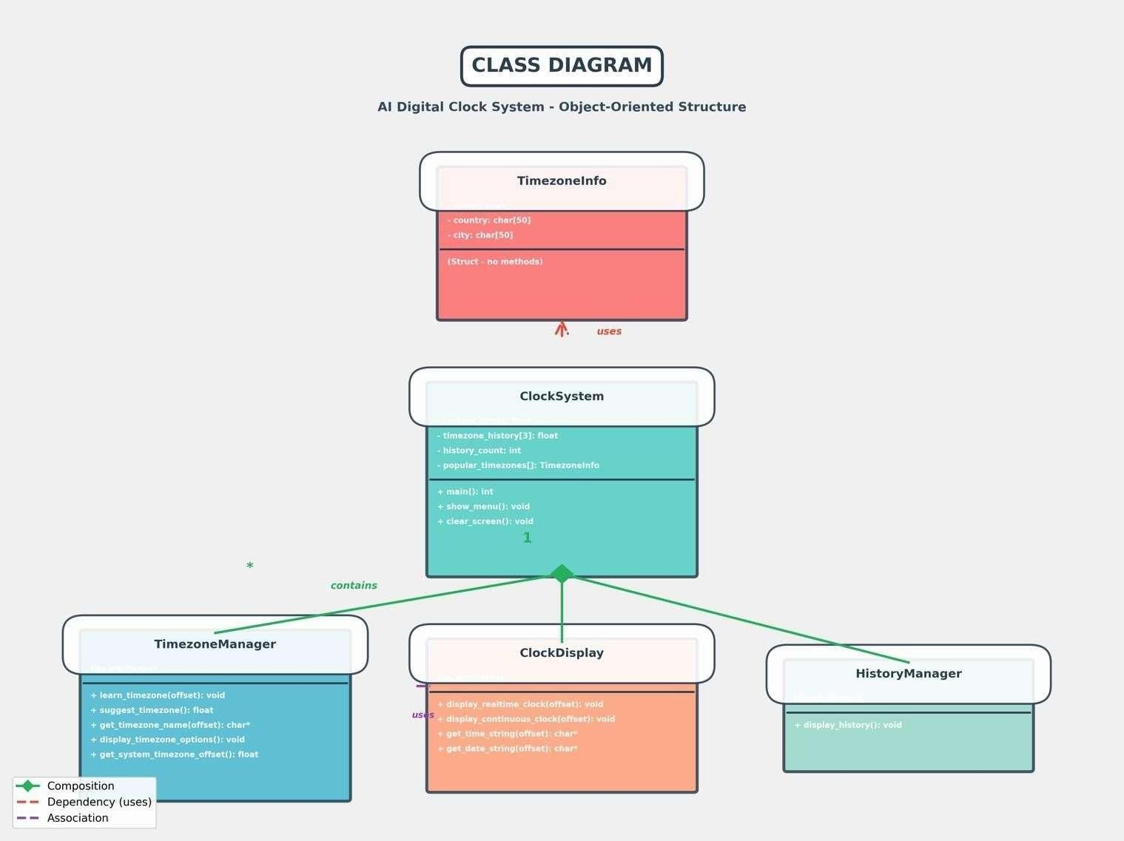

Figure 8.4: Class Diagram

METHODOLOGY

Software Development Life Cycle Model

For developing the AI-Enhanced Digital Clock project, we selected the Iterative Model as our software development approach. This model allows us to build our project step by step, making it easier to manage and improve.

What is the Iterative Model?

The Iterative Model breaks down the whole project into smaller; manage able pieces called "iterations." Each iteration builds upon the previous one, gradually creating a complete system. Think of it like building with blocks – we start with a basic foundation and add more blocks in each iteration until we have a complete structure.

Phases in Each Iteration

Every iteration follows four simple steps:

- Requirement & Planning: Decide what features to add and make a simple plan
- Design & Development: Design how the feature will work and write the code
- Testing: Test new features, check integration with existing code, and fix bugs
- Review & Feedback: Evaluate the work and note improvements for next iteration

Why We Chose This Model

Flexibility: Easy to fix mistakes and add new ideas in the next iteration
Early Proto types: Get a working version very early in development
Risk Management: Problems are caught and fixed early before becoming major issues
Learning While Building: Learn programming concepts gradually without feeling overwhelmed

Our Project's Iterative Development

Iteration1: Built basic time display and simple menu system
Iteration2: Added time zone support for 5 countries (USA, India, China, UK, France)
Iteration 3: Implemented real-time display with continuous updates every second Iteration 4: user interface, added colors, and wrote documentation.

Benefits We Experienced

Using the Iterative Model helped using practical ways:

- Better Understanding: We understood each part before moving to the next
- Easy Debugging: We knew exactly which iteration introduced bugs
- Gradual Progress: We saw improvements with each iteration, keeping us motivated
- Flexible Changes: When we discovered India uses UTC+5:30,we easily fixed it in the next iteration
- Working Product: Even after iteration1, we had a working clock to demonstrate

Conclusion

The Iterative Model proved perfect for our first-year project. It allowed us to learn, build, test, and improve our Digital Clock systematically. This step-by-step approach made a complex project manageable for beginners, and we gained valuable programming experience along the way.

- CODING

#include <iostream>
#include <windows.h>
#include <ctime>
#include <conio.h>

using namespace std;

// Cursor movement
void gotoxy(int x, int y) {
COORD coord;
coord.X = x;
coord.Y = y;
SetConsoleCursorPosition(GetStdHandle(STD_OUTPUT_HANDLE), coord);
}

// Color
void setColor(int color) {
SetConsoleTextAttribute(GetStdHandle(STD_OUTPUT_HANDLE), color);
}

// Hide cursor
void hideCursor() {
CONSOLE_CURSOR_INFO cursor;
cursor.dwSize = 100;
cursor.bVisible = FALSE;
SetConsoleCursorInfo(GetStdHandle(STD_OUTPUT_HANDLE), &cursor);
}

// Format time
string formatTime(tm* t) {
char buffer[20];
sprintf(buffer, "%02d:%02d:%02d", t->tm_hour, t->tm_min, t->tm_sec);
return string(buffer);
}

// Local time
string getTime() {
time_t now = time(0);
return formatTime(localtime(&now));
}

// World time
string getWorldTime(int offset) {
time_t now = time(0) + offset * 3600;
return formatTime(gmtime(&now));
}

// Date
string getDate() {
time_t now = time(0);
tm* t = localtime(&now);

char buffer[50];
strftime(buffer, sizeof(buffer), "%A, %d %b %Y", t);
return string(buffer);
}

// Stopwatch
void runStopwatch() {
int sec = 0;
while (!_kbhit()) { // press any key to exit
int h = sec / 3600;
int m = (sec % 3600) / 60;
int s = sec % 60;

setColor(10);
gotoxy(5, 10);
printf("STOPWATCH: %02d:%02d:%02d", h, m, s);

Sleep(1000);
sec++;
}
getch(); // clear key
}

// Timer
void runTimer() {
int total;
gotoxy(5, 10);
cout << "Enter seconds: ";
cin >> total;

while (total >= 0) {
int h = total / 3600;
int m = (total % 3600) / 60;

int s = total % 60;
setColor(12);
gotoxy(5, 11);
printf("TIMER: %02d:%02d:%02d ", h, m, s);

Sleep(1000);
total--;
}

setColor(14);
gotoxy(5, 12);
cout << "Time's up! \a";
}

// World clock display
void showWorldClock() {
while (!_kbhit()) {
setColor(11);
gotoxy(40, 2);
cout << "China : " << getWorldTime(8);

gotoxy(40, 3);
cout << "UK : " << getWorldTime(0);

gotoxy(40, 4);
cout << "France: " << getWorldTime(1);

gotoxy(40, 5);
cout << "USA : " << getWorldTime(-4);

Sleep(1000);
}
getch();
}
// Main system
int main()
{
system("cls");
hideCursor();

while (true) {

// ALWAYS RUNNING CLOCK
setColor(10);

gotoxy(5, 2);
cout << "TIME: " << getTime() << " ";

setColor(13);
gotoxy(5, 3);
cout << getDate() << " ";

// Instructions
setColor(11);
gotoxy(5, 6);
cout << "Press:";
gotoxy(5, 7);
cout << "1 - World Clock";
gotoxy(5, 8);
cout << "2 - Stopwatch";
gotoxy(5, 9);
cout << "3 - Timer";
gotoxy(5, 10);
cout << "Q - Quit";

// Key detection
if (_kbhit()) {
char ch = _getch();

if (ch == '1') {
showWorldClock();
}
else if (ch == '2') {
runStopwatch();
}
else if (ch == '3') {
runTimer();

}
else if (ch == 'q' || ch == 'Q') {
break;
}
}

Sleep(1000);
}
return 0;
}

OUTPUT

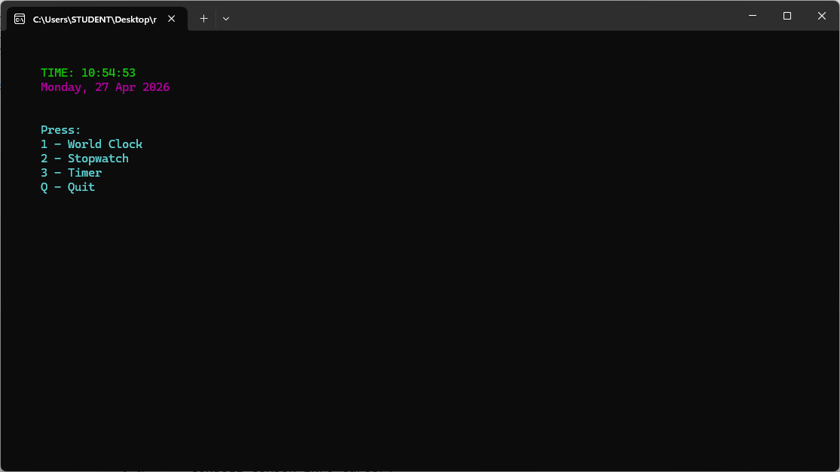

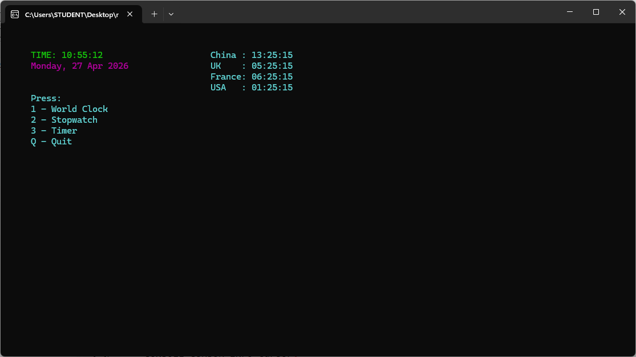

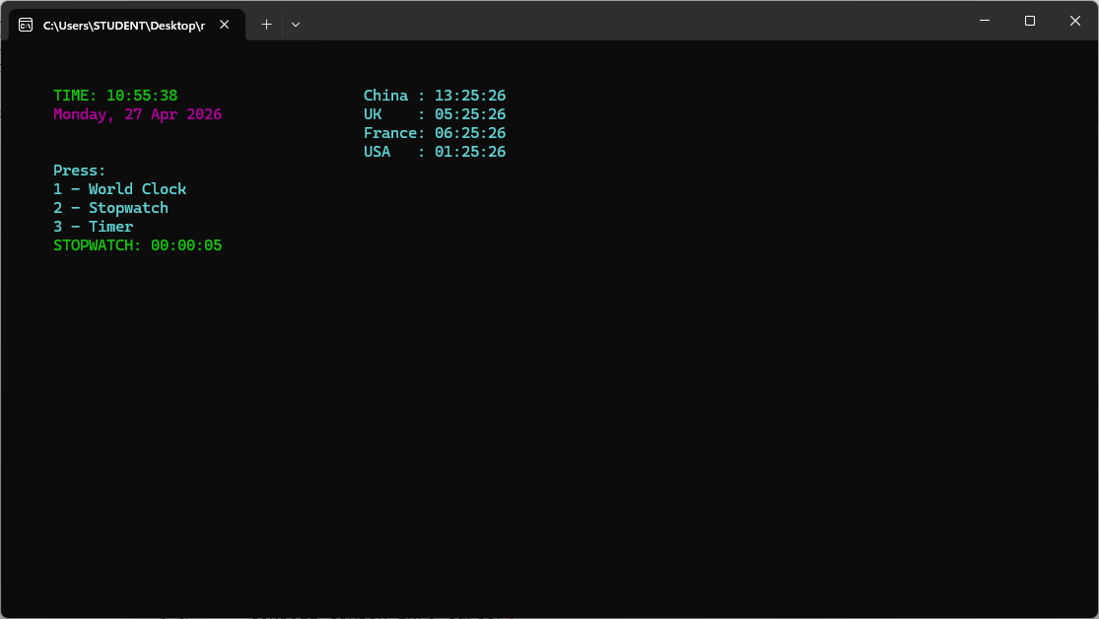

REFERENCE

- github- https://github.com
- Geeksforgeeks- https://www.geeksforgeeks.org/
- Digital clock algorithm- https://www.geeksforgeeks.org/cpp/digital-clock-starting-from-user-set-time-in-cpp/
- C++ Tempelates: The complete Guide by David Vandevoorde and Nicolai M. Jousuttis- https://share.google/JcBlMN2JVb6jVdB65

